# **Setup steps for SSH connections to AWS CodeCommit repositories on Window**

**STEP 1**:

* Open Command Prompt
* Type the command :**ssh-keygen** and follow the directions to save the file to the **.ssh directory** for your profile.

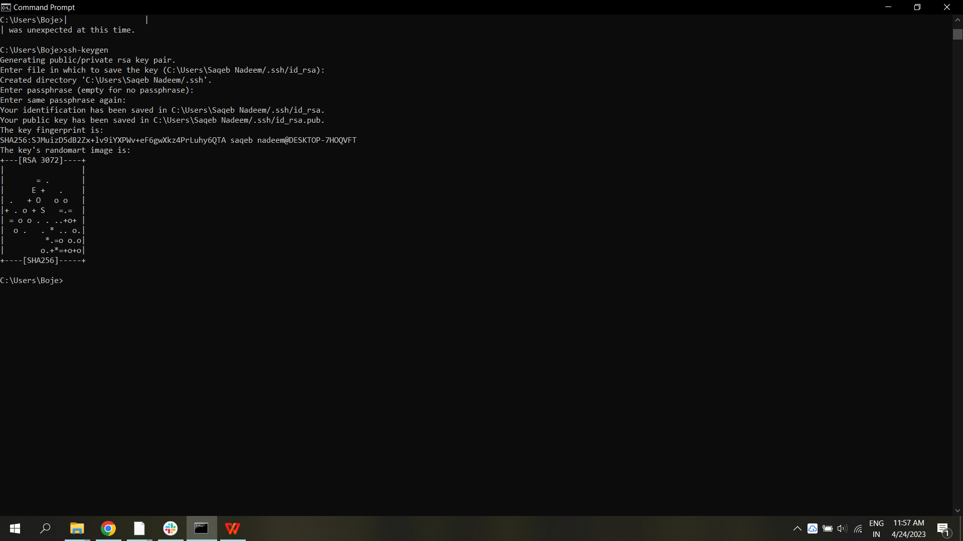

The Public and Private Key will generate in the .ssh Path

**STEP 2**:

Go to ssh key Path and Copy the **Public key**

* And Select IAM USER from the IAM Console.Select the **Security Credentials** option on the user details page, and then select **Upload SSH public key**..
* Paste the contents of your SSH public key into the field, and then choose **Upload SSH public key**.

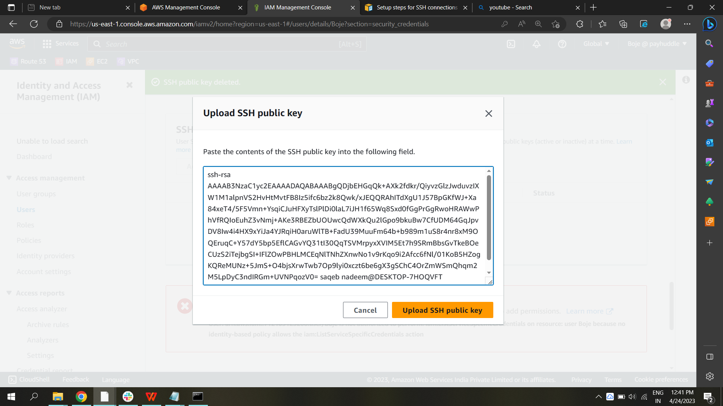

**STEP 3**:

* After Paste it status will active and copy the **SSH Key ID**

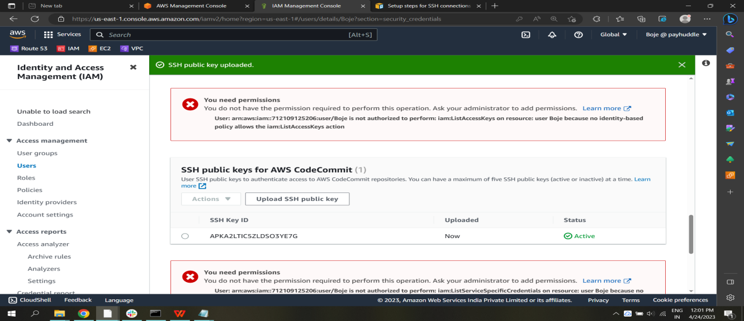

* And **SSH Key ID** Paste in **Config file** and identity file path give public and private key name.

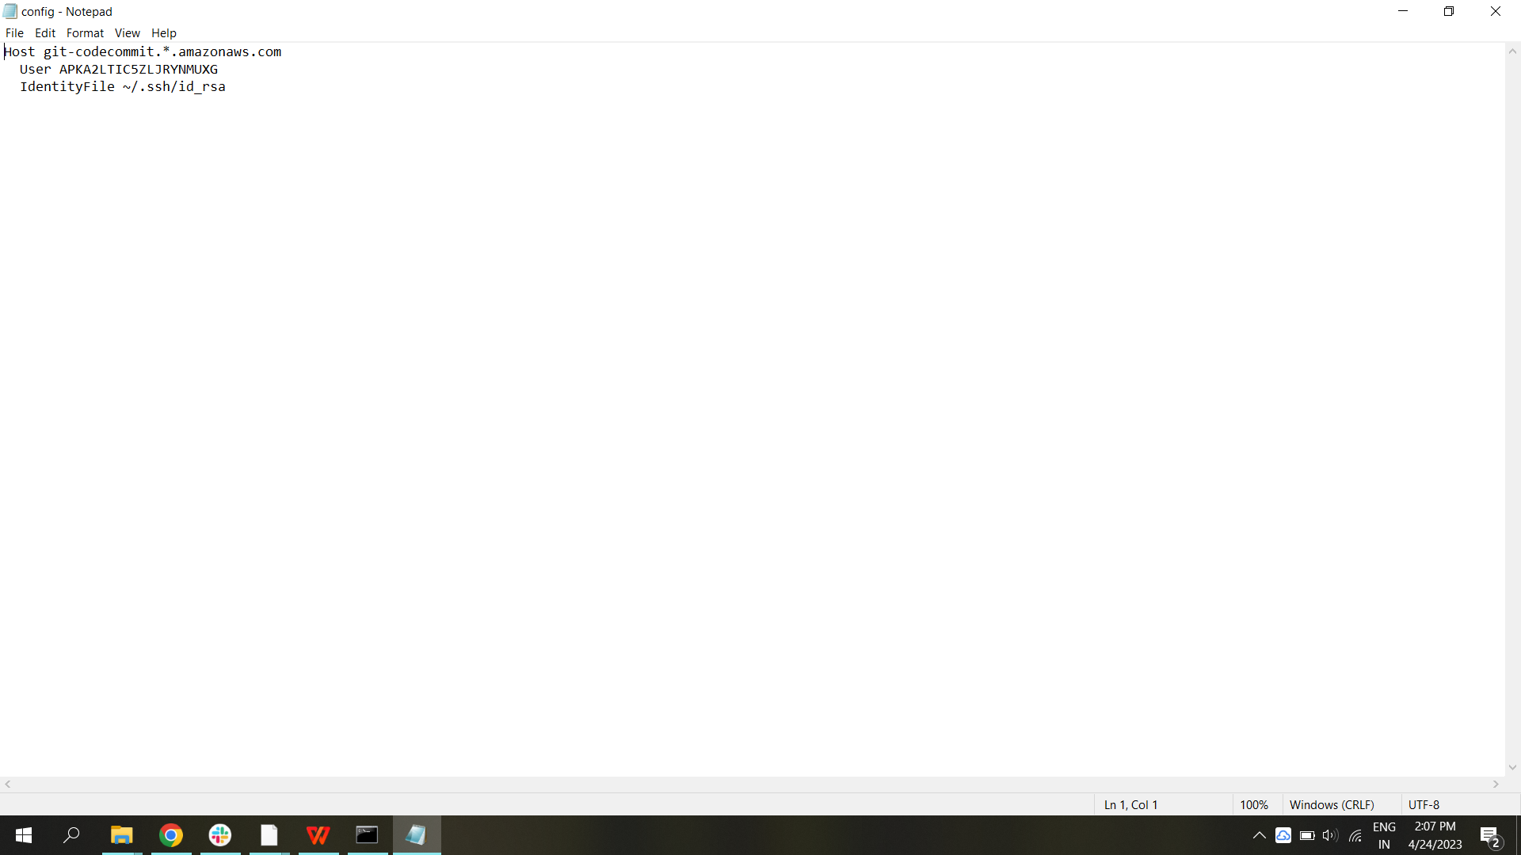

**STEP 4** ;

* Run the command to test your SSH configuration :**ssh git-codecommit.us-east-2.amazonaws.com** (It is ssh key link of codecommit)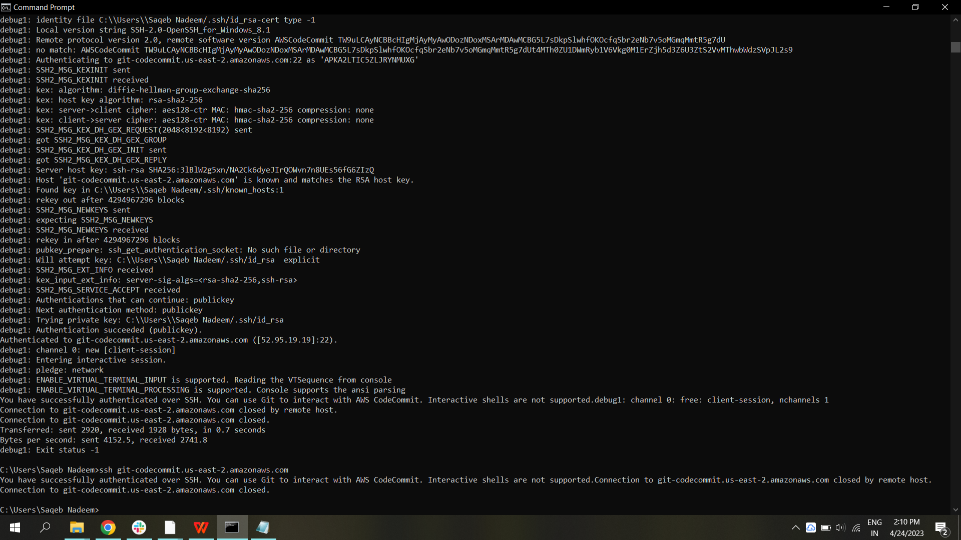
* To troubleshoot problems, run the ssh command with the -v parameter

**STEP 5 :**

* Download the tortoise git [Download TortoiseGit 2.14.0.1 64-bit](https://download.tortoisegit.org/tgit/2.14.0.0/TortoiseGit-2.14.0.1-64bit.msi) (21.6 MiB)
* In Installing Process Select the **Open SSH**

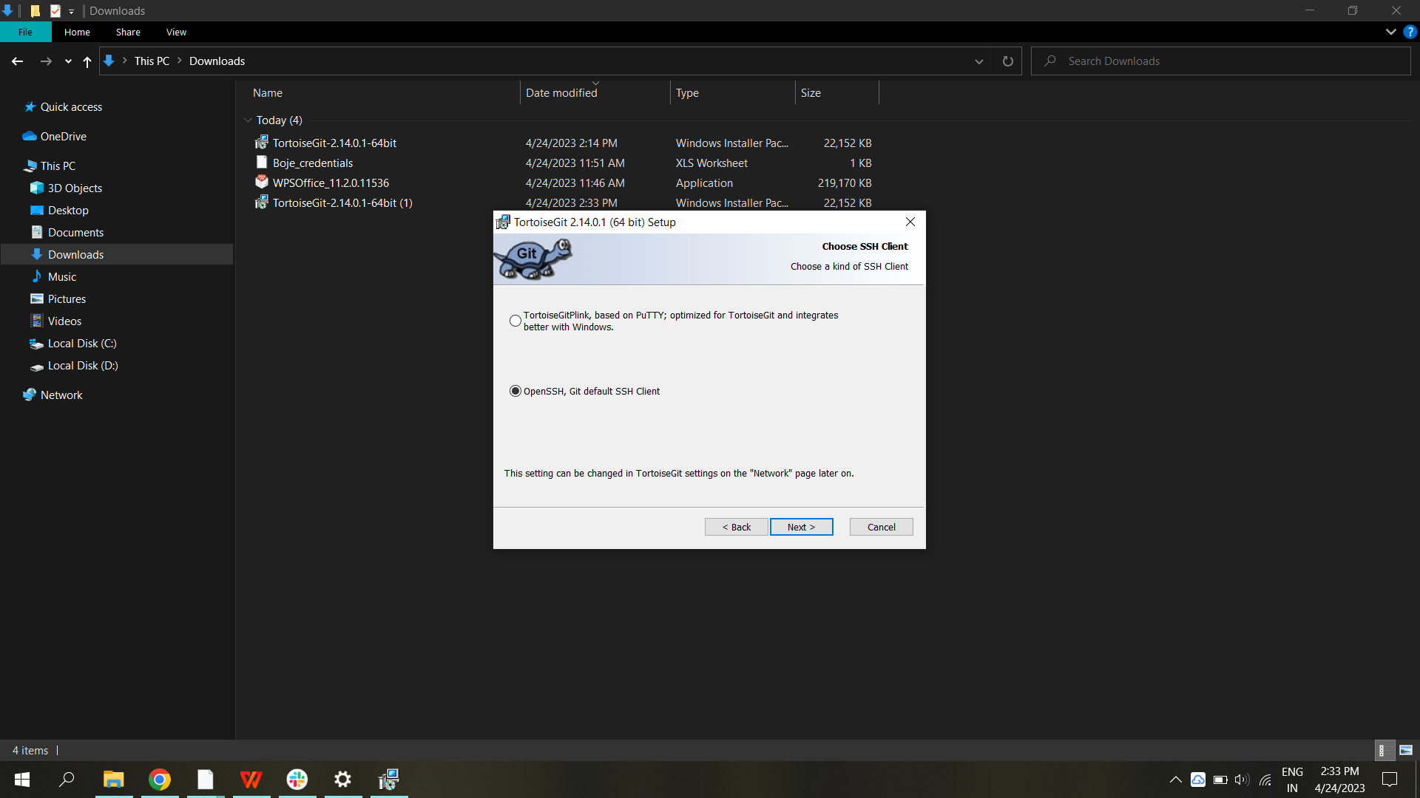

* Connect to the CodeCommit console and clone the repository and **Copy the SSH clone** Paste in **TortoiseGit**

